PATIENT NAME:
INSURANCE ID#: DOB:
ADDRESS:
PHONE #:
MEDICARE DESCRIPTION AND PROCEDURE CODES:
- STANDARD POWER OPERATED VEHICLE GROUP1:K0801 #1
- POWER WHEELCHAIR BATTERY, GROUP U-1 - E23651 #2
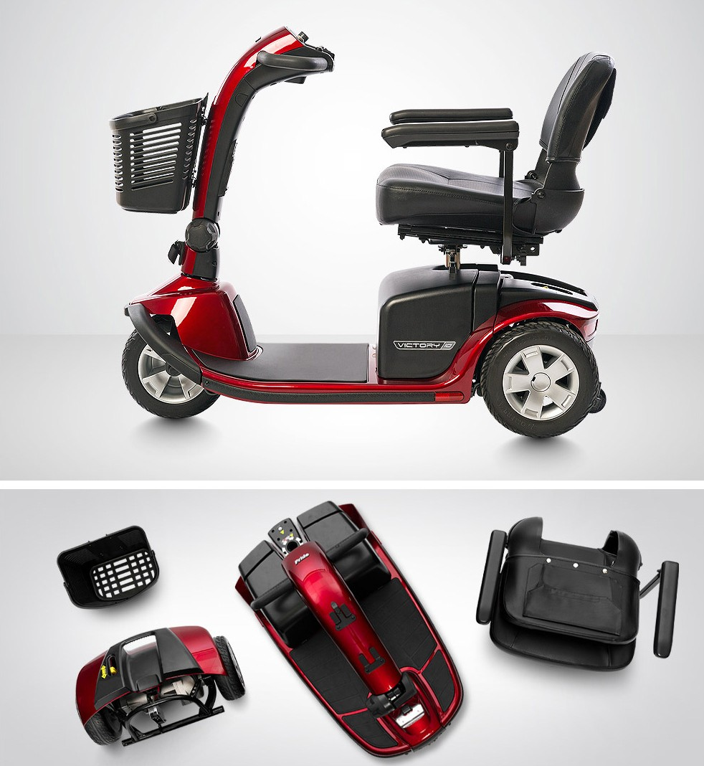

CATEGORY | SPECIFICATION
Model | Victory 10 3-Wheel
Model Number1 | S610
Number or Tires | 3
Front Tires2 | 3.5"x10" Solid
Rear Tires2 | 3.5"x10" Solid
Maximum Speed8 | Up to 5.3 mph
Ground Clearance2 | 2.2" at motor; 3.4" at side deck
Turning Radius2 | 42"
Length2 | 45.25"
Width2,4 | 22.25"
Seat-to-Ground Height Range2 | 23.5"-25"
Seat-to-Deck Range2 | 17.5"-19"
Standard Seat Type | Compact, Foldable;  Materal: Black Vinyl;  Seat Size: 18"x17"
Weight Without Batteries2 | 133 lbs.
Weight With Batteries | 4-wheel (U1)- 185 lbs.
Weight of Heaviest Piece2 | 54 lbs. (front section)
Battery Weight6 | U1- 24 lbs. each; 40AH (optional) -32 lbs. each
Battery Requirements7 | (2) U1 (standard); (2) 40AH (optional)
Per Charge Range (max)8,9 | Up to 15.5 miles
Battery Charger | Off-board, 3A (U1); Off-board, 5A(40AH)
Suspension | NA
Maximum Weight Capacity | 400 lbs.
HCPCS Code | K0801- Group 1 Heavy Duty
Warranty | Lifetime limited on frame;  2-year limited on electronics;  2-year limited on drivetrain

**Patient Agreement:** I, ___________________________________ (Patient Name), acknowledge that I have reviewed the power scooter depicted in the accompanying picture. I understand its features and specifications and agree that this wheelchair meets my mobility needs as assessed by my healthcare provider. I consent to accept and use this specific power wheelchair as part of my mobility solution.

Patient’s Signature:__________________________________________________________ Date:_____________
Signature if other than patient:___________________________________Relationship:____________________
Name if other than patient:______________________________________________________________________
Reason patient is unable to sign:__________________________________________________________________
Evaluator’s Signature:_____________________________________________________ Date:________________
Evaluator’s Name (printed):_____________________________________________________________________

